I have worked about Ultima Thule.
Ultima Thule is a swedish band and there are four members in the band today.
The members name is Janne Thörnblom Ulf Hansen, Thomas Krohn, Nicklas Adolfsson.
In the beginning they were 5 members, the fifth member was called Bruno.
But he left the band just after the come-back.
The band was grounded back in 1984 but before that had the boys been playing music together for a couple of years.
They got the name Ultima Thule from Ulf Hansen´s brother.
Their first single “Sverige, Sverige fosterland” was sponsored by the organization BSS with 1500 swedish crowns.
The band was splitted in 1986, one year after the first single.
It took 4 years to start the band again. The band was going to made a record with old Ultima Thule songs. And it was now they decided to start the band again.
Bert Karlsson got news about that and he knew that he could earn money on Ultima Thule
and he wrote a contract with them.
Soon they were popular again and they were one of the most popular
band in Sweden.
Then the critics came and they said that Ultima Thule is singing racistic music.
So after that did Bert Karlssons company kick them out so they couldn´t do any more records on Mariann Record.
Today the members is very rich and they got their own recordstudio in Nyköping.
The studio is called “Valhall”.
In year 2000 a swedish newspaper wrote about the band.
It was an interview with one of the members of the band. They wrote about what this member think about many questions.
Just a few weeks later someone had put a bomb in the bands recordstudio and the band got a lot of publicity again. The studio was totally damaged and also nearly the whole house.
TV channel number 3 told about the incident and they also talked about that these incidents with bombs often is crimes for getting the insurance money.
But nobody could proof that the band was guilty and I do not think that they would damage their recordstudio with a lot of invaluable originalrecords.
Then it was quiet about that. The police did not seem to make so big efforts to solve the crime.
Many people think that Ultima Thule is racists.
The members of the band says that they are not racists and that they will not have something to do with racists and racistic organizations.
The band says that they have never sang a racistic song.
But others think that the meaning in the songs sounds different depending on who is listening to the songs.
One of their most popular songs is called “Stolt och Stark”.
Some people thought that this song was about refugees but the band says that it is about politicians. If you look at the text of the song you can think that it is an ordinary song but rather strong, but a man against refugees think that the song supports his opinion.
If the members are racists or not, that is very hard to decide. But even if they are against racism now, they have had done things that make people believe that they are racists.
They have for example played on a consert where racistic organizations played.
My big idol is Eddie Meduza and Ultima Thule has worked with him.
Eddie and the band has made some songs together.
That is why I think that some of the bands music is good.
I also like some of their own songs, but not all of them.

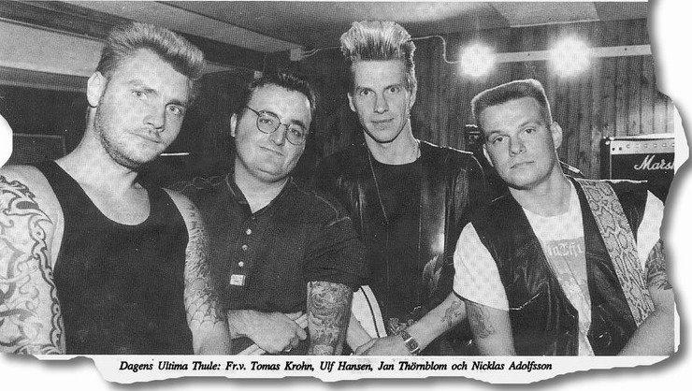

Daniel Ohlsson

